GITHUB link : CLICK ON THIS LINK FOR MY GITHUB PAGE

Answer 1 : ------------->>>>>>>

import java.util.*;
class demo1{
public static void main(String args[])
{
List<String> str = new ArrayList<String>();
str.add("Mango");
str.add("Banana");
str.add("orange");
str.add("chiku");
str.add("apple");
str.add("Pineapple");

for(String s: str)
{
System.out.println(s);
}
}
}
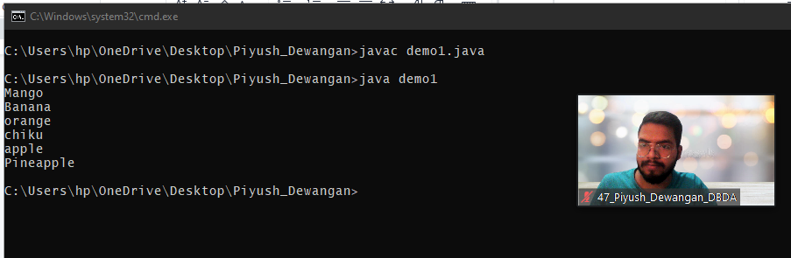

--------------------------------------------------------------------------------------------------------------------------

Answer 3 : ------------->>>>>>>>>

class Shape
{
void draw()
{
System.out.println("Drawing Shape");
}
void erase()
{
System.out.println("Erasing Shape");
}
}
class Circle extends Shape
{
void draw()
{
System.out.println("Drawing Shape Circle");
}
void erase()
{
System.out.println("Erasing Shape Circle");
}
}
class Triangle extends Shape
{
void draw()
{
System.out.println("Drawing Shape Triangle");
}
void erase()
{
System.out.println("Erasing Shape Triangle");
}
}
class Square extends Shape
{
void draw()
{
System.out.println("Drawing Shape Square");
}
void erase()
{
System.out.println("Erasing Shape Square");
}
}
public class demo3
{
public static void main(String args[])
{
Shape c = new Circle();
Shape t = new Triangle();
Shape s = new Square();

c.draw(); c.erase();
t.draw(); t.erase();
s.draw(); s.erase();
}
}

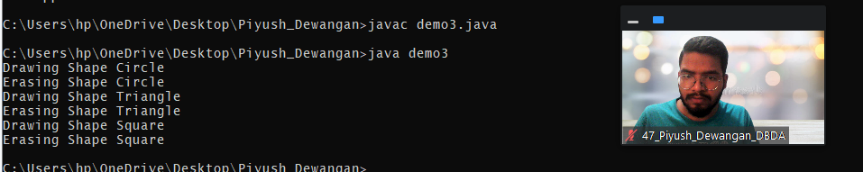

--------------------------------------------------------------------------------------------------------------------------

Answer 2 ------------------>>>>>>>>

import java.util.*;
class WithdrawingMoreThanBalance extends Exception
{
WithdrawingMoreThanBalance(String s)
{
super(s);
}
}
class BankAccount
{
private String account_no;
private double balance;

BankAccount(String account_no, double balance)
{
this.account_no = account_no;
this.balance = balance;
}
void getDetails()
{
System.out.println(account_no);
System.out.println(balance);
}
public void deposit(double depositAmt)
{
balance = balance + depositAmt;
}
public void withdraw(double withdrawAmt) throws WithdrawingMoreThanBalance
{
if (balance < withdrawAmt)
{
throw new WithdrawingMoreThanBalance("Balance is less than the Withdrawal Amount !...");
}
else
{
balance = balance - withdrawAmt;
}
}
}
public class demo2
{
public static void main(String args[])
{
BankAccount bnk1 = new BankAccount("ABC123", 4000.20);
BankAccount bnk2 = new BankAccount("XYZ", 205);
Scanner inp = new Scanner(System.in);

System.out.println("\nAccount number and Balance of user 1 :");
bnk1.getDetails();
System.out.println("Account number and Balance of user 2 :");
bnk2.getDetails();

double d1 = inp.nextDouble();
double d2 = inp.nextDouble();
bnk1.deposit(d1);
bnk2.deposit(d2);
System.out.println("\nAdding Rs."+d1+" to account 1");
System.out.println("Adding Rs."+d2+" to account 2");

System.out.println("\nAccount number and Balance of user 1 :");
bnk1.getDetails();
System.out.println("Account number and Balance of user 2 :");
bnk2.getDetails();

double w1 = inp.nextDouble();
double w2 = inp.nextDouble();
try
{
bnk1.withdraw(w1);
System.out.println("\nWithdrawing Rs."+d1+" from account 1");
bnk2.withdraw(w2);
System.out.println("Withdrawing Rs."+d2+" from account 2");
}
catch(WithdrawingMoreThanBalance e)
{
System.out.println(e);
}

System.out.println("\nAccount number and Balance of user 1 :");
bnk1.getDetails();
System.out.println("Account number and Balance of user 2 :");
bnk2.getDetails();
}
}

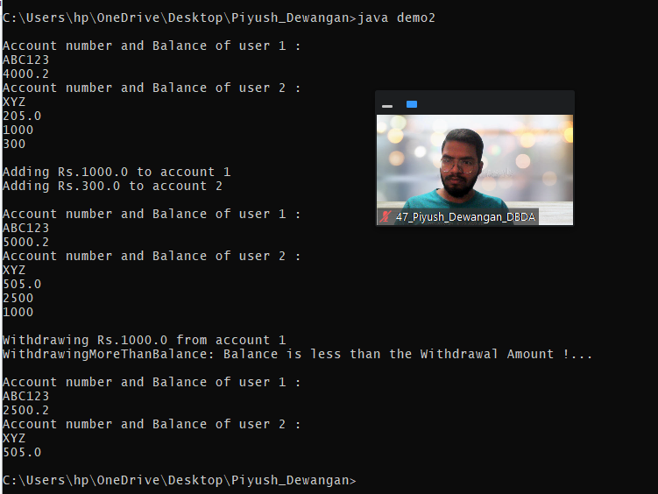

--------------------------------------------------------------------------------------------------------------------------

Answer 4 : ------------>>>>>>>>>

class GrandParent
{
String grandFatherName;
String grandMotherName;

GrandParent(String grandFatherName, String grandMotherName)
{
this.grandFatherName = grandFatherName;
this.grandMotherName = grandMotherName;

System.out.println("Grand Father name is : "+grandFatherName);
System.out.println("Grand Mother name is : "+grandMotherName);
}
}
class Parent extends GrandParent
{
String FatherName;
String MotherName;

Parent(String grandFatherName, String grandMotherName, String FatherName, String MotherName)
{
this(grandFatherName, grandMotherName);

this.FatherName = FatherName;
this.MotherName = MotherName;

System.out.println("Father name is : "+this.FatherName);
System.out.println("Mother name is : "+this.MotherName);
}
Parent(String grandFatherName, String grandMotherName)
{
super(grandFatherName, grandMotherName);
}
}
class child extends Parent
{
child(String grandFatherName, String grandMotherName, String FatherName, String MotherName)
{
super(grandFatherName,grandMotherName,FatherName,MotherName);
}
public static void main(String args[])
{
child c = new child("Ramesh","Swati","Raj Kumar","Roop mati");
}
}

